Sentiment Analysis of Tweets [UPA VS NDA]

By Akshay Saxena

Ridgeant Technologies

The Analysis Performed is based on manual Keywords to form dataset

Overview

Sentimental Analysis form the pillars of feedback analysis. It is essential to determine sectors and departments that need to be brushed up according to future requirements. The applications vary from business point of view to understanding changing trends in Technologies, Culture, fashion, Economics, Politics and a lot many components of society.

This Project highlights the sentimental analysis of 20k tweets dataset in context of major Indian Political Alliances: NDA and UPA. Forming up Manual keywords and matching their availability within the tweets dataset. The matched tweets are passed for sentimental analysis.

The results are presented in bar graph and figures are in console window.

There are 2 methods provided by twitter API to fetch the tweets i.e. using streamer and API.

Streamer method captures the live tweets and API fetches the tweets from past. For proper analysis, this project uses API method.

Sentiment Analysis of Tweets [UPA VS NDA]

# Modules:-

* Fetch
* Filter
* Sentiment
* Plot

**Libraries:-**

* **Pandas[for dataframes]**
* **Tweepy[for fetching tweets]**
* **Textblob[for sentimental analysis]**
* **Matplotlib[for plotting graphs]**
* **Openpyxl[reading xlsx files]**
* **Numpy[for handling arrays]**
* **Re[for operations on regular expressions]**
* **Csv[for reading csv files]**

##### Flowchart:-

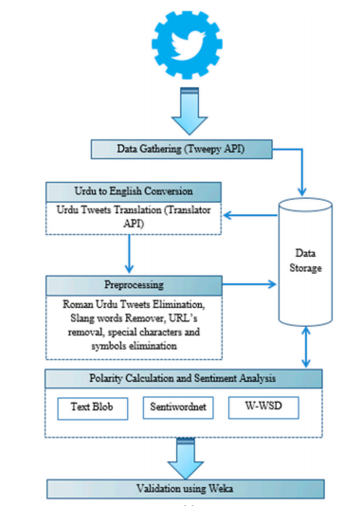

The last module i.e. validation using weka is excluded in this project

**CHALLENGES**

* Rate Limit of tweepy during fetching the tweets
* Filtering out URLs embedded within tweets text
* Mentioning keywords on final plot that define the relevant tweets
* Defining Sentiment function and allotting value to positive, negative and neutral dictionaries.
* Inconsistency in making sense out in some sentences as the result of textblob library is based off on aggregation of words.

Fig-1

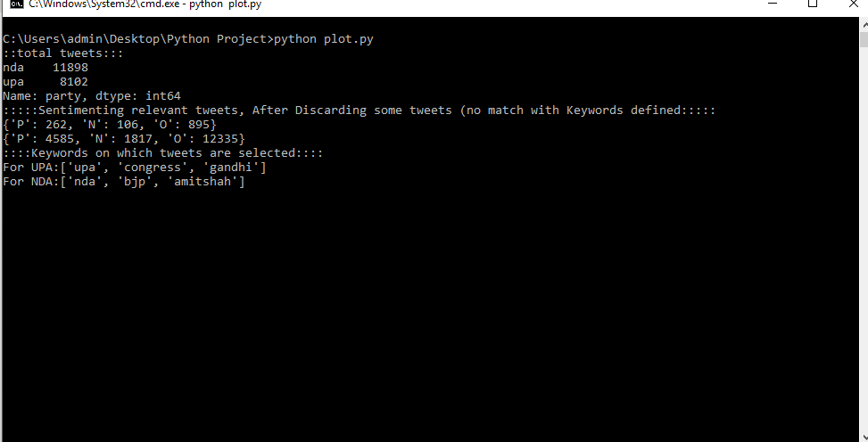 Figure-2

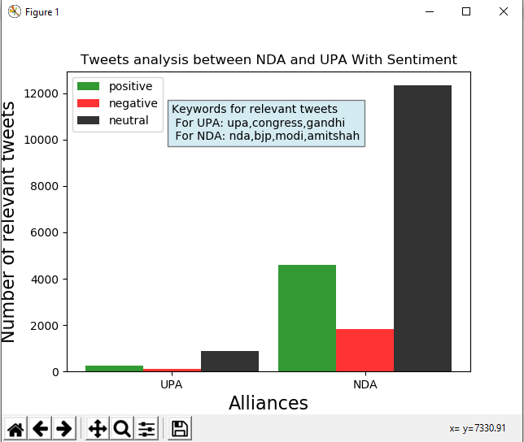

Figure - 3

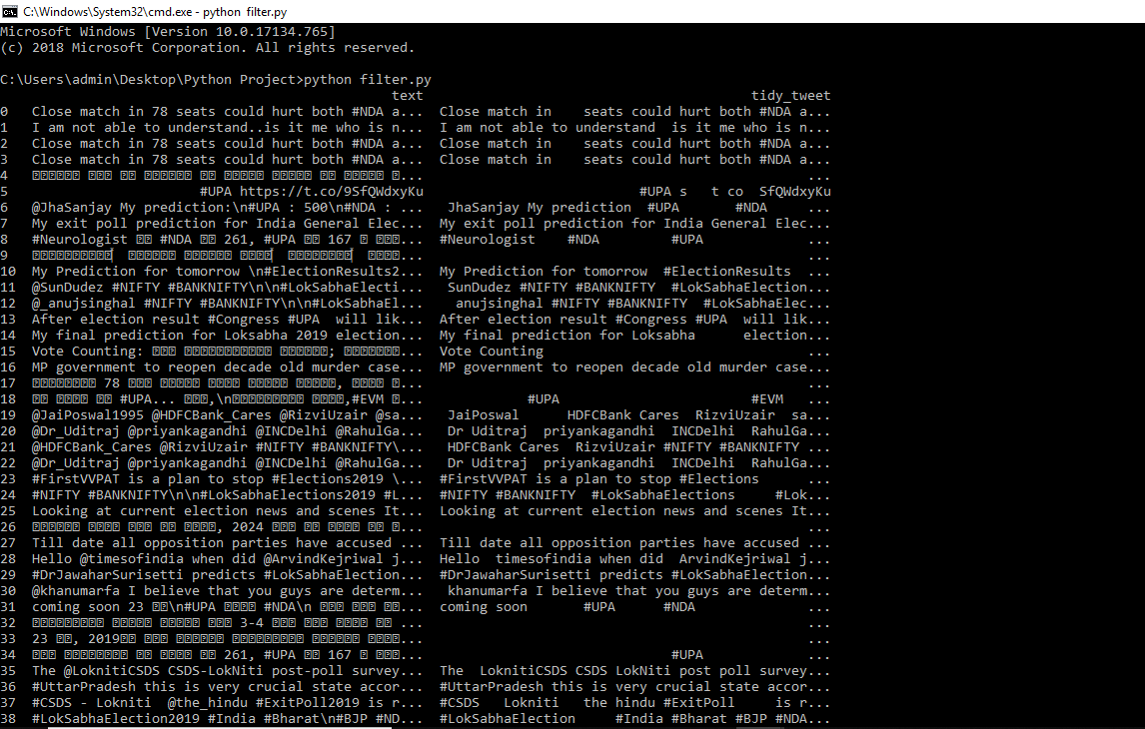

Figure 1. Showing the analyzed data

*Figure 2.* Showing the plot of sentiments

*Figure 3.* Showing the Filtered data frame [right] from fetched tweets dataset [left]